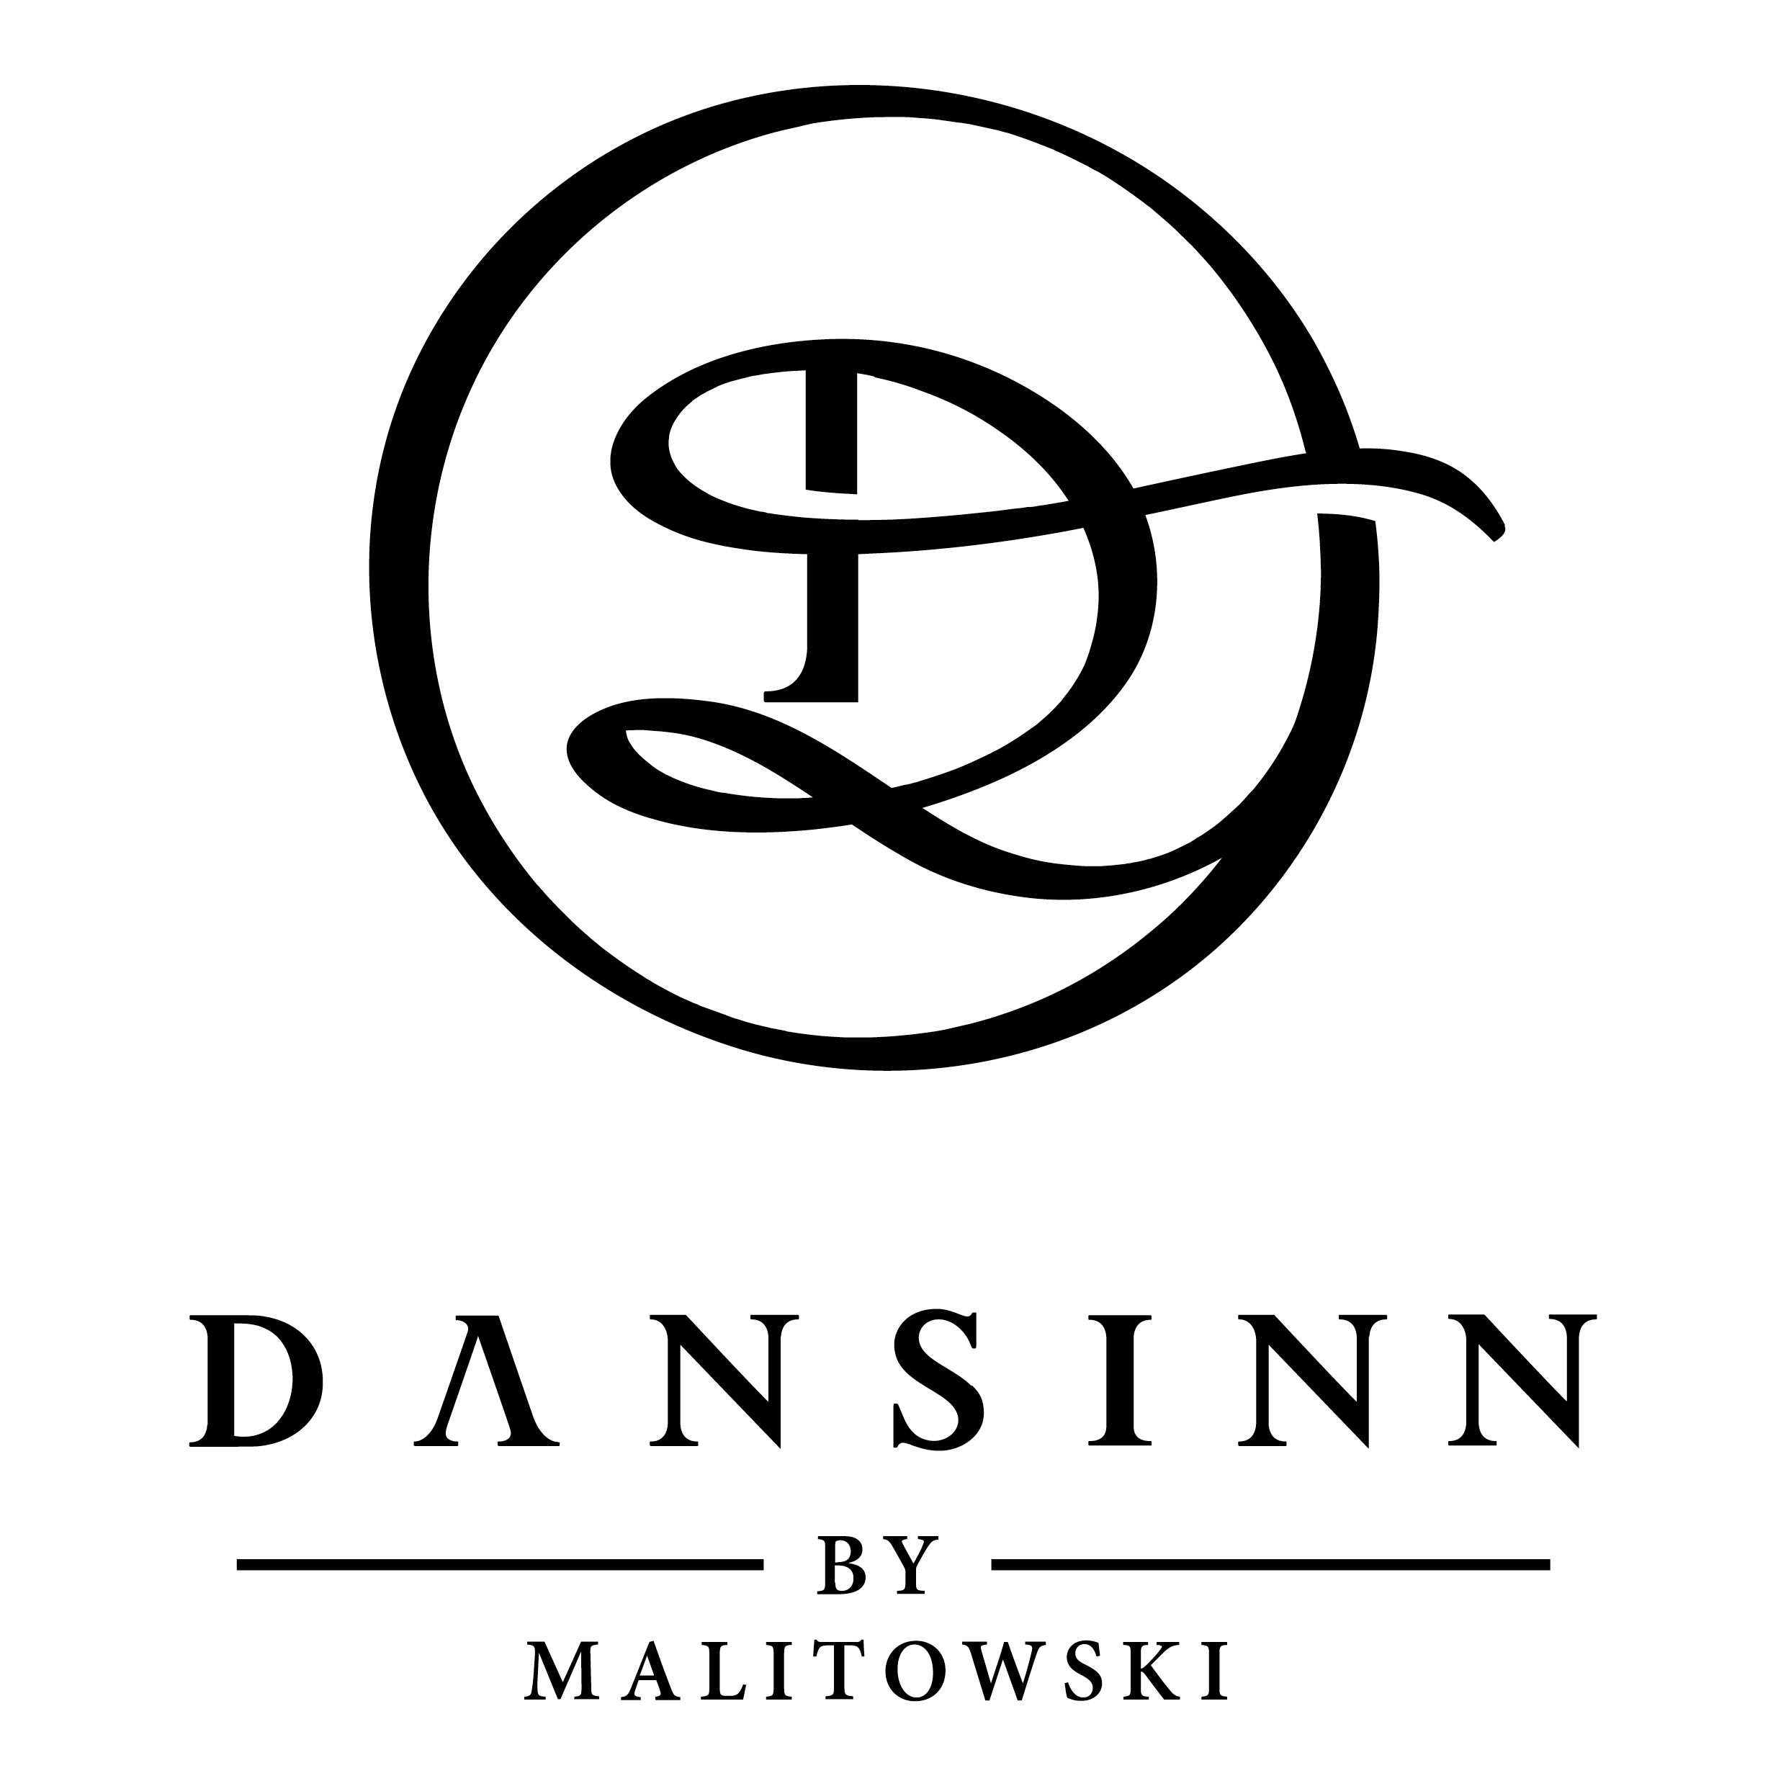
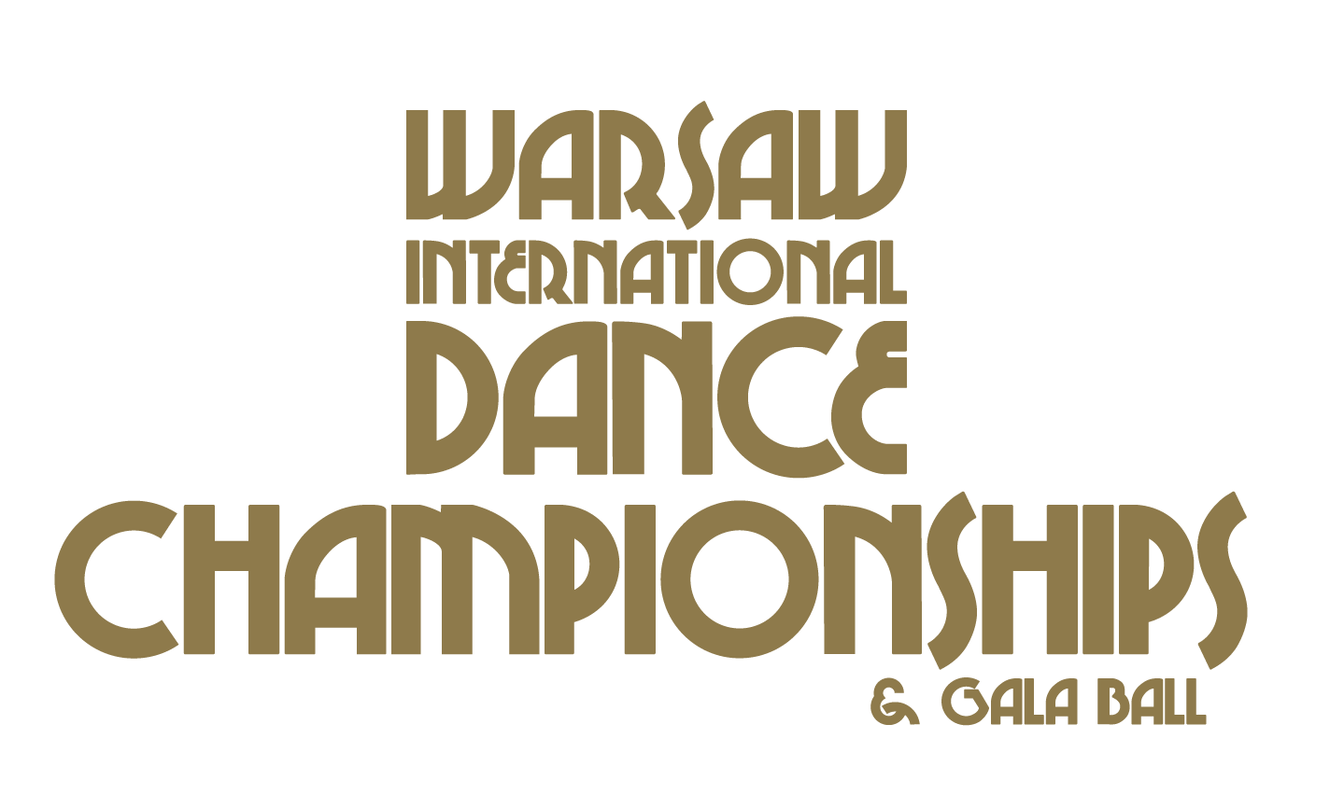

SOLO ENTRY FORM 3.09.2023
Professional name and surname:
Amateur name and surname:
Country:
e-mail:
Telephone no:
ProAm Age CATEGORIES
Please circle age
Under 8 Under 10 Under 12
Under 14 Under 16 Under 19
Adults
SINGLE DANCE
Please Circle Appropriate Dance Below
LEVEL | INT. BALLROOM | INT. LATIN
Open | W T Vw Fx Q | CC S R PD J

MULTI DANCE
Please Circle Appropriate dance below
2 DANCE CHALLENGE
LEVEL | INT BALLROOM | INT LATIN
Open | W / T | CC / R

3 DANCE CHALLENGE
LEVEL | INT BALLROOM | INT LATIN
Open | W / T / Q | CC / R / J

4 DANCE CHALLENGE
LEVEL | AM. SMOOTH | AM. RHYTHM | INT BALLROOM | INT LATIN
Open | W / T / Fx / Vw | CC / R / SW / B | W / T / Vw / Q | CC / S / R / J

SCHOLARSHIPS
Please Circle an Appropriate Category Below
AGE | INT BALLROOM | INT LATIN
Under 8 | W / T / Vw / Fx / Q | CC / S / R / PD / J
Under 10 | W / T / Vw / Fx / Q | CC / S / R / PD / J
Under 12 | W / T / Vw / Fx / Q | CC / S / R / PD / J
Under 14 | W / T / Vw / Fx / Q | CC / S / R / PD / J
Under 16 | W / T / Vw / Fx / Q | CC / S / R / PD / J
Under 19 | W / T / Vw / Fx / Q | CC / S / R / PD / J
Adults | W / T / Vw / Fx / Q | CC / S / R / PD / J

WIDC Open Championships
Please Circle an Appropriate Category Below
AGE / LEVEL | INT BALLROOM | INT LATIN
All ages and Levels | W / T / Vw / Fx / Q | CC / S / R / PD / J

ENTRY FEES
ENTRY | EARLY BIRD 1  If you pay before 15th of June 2023 | EARLY BIRD 2  If you pay before 1st of August 2023 | REGULAR  After 1st of August 2023
Solo Single Dances | 10 Euro | 15 Euro | 20 Euro
Solo 2 Dance Challenges | 15 Euro | 20 Euro | 30Euro
Solo 3 Dance Challenges | 25 Euro | 30 Euro | 35 Euro
Solo 4 Dance Challenges | 30 Euro | 35 Euro | 40 Euro
Solo Scholarships | 50 Euro | 60 Euro | 70 Euro
WIDC Open Championships | 50 Euro | 60 Euro | 70 Euro

Registration will be closed on the 25th of August 2023

Please register with:
www.dansinnevents.com
If you have any questions don’t hesitate to call us:
WhatsApp: +48 609 466 996
Payment Details:
Company Name: Dansinn by Malitowski Sp. z o.o.
Company Address: Mińska 65
Postal Code: 03-828
City: Warszawa

Bank Account: PL 66 1750 0012 0000 0000 3760 9404
SWIFT CODE: RCBWPLPW (account in Euro)
Bank address: Piekna 20
City: Warszawa
Postal Code: 00-549

Deadline for entries is 25th of August, 2023.

Warsaw International Dance Championships 2023 takes place on the 2nd and 3rd of August 2023 at the
DoubleTree by Hilton ul. Skalnicowa 21, 04-797 Warsaw Poland.

Shortly after we received your information, we will send you an invoice/confirmation with payment options. Please check this closely for spelling, correct entries, and correct charges and let us know immediately if we need to make changes. Please be advised that at the competition we may not have the time to make changes or take additional entries.

A couple is counted as “registered” only then, when required registration form has been submitted in the specified time period and all the required payments have been made. Once registered and paid, but not present in the competition (haven’t arrived) no refunds will be provided to the couple.

If the couple has, for any reason, made contact and informed the organizers about their cancelation after the 13th of August 2023, no payment refunds (including Packages, Entry tickets, entry fees etc.) will be provided back to the couple or person who paid.

With Warm Regards,

Piotr Lewandowski.
CEO
TIDC & Gala Ball / WIDC & Gala Ball / Grand Final Championships
Dansinn by Malitowski
+46 609 466 996
p.lewandowski@dansinn,pl

WIDC & Gala Ball 2023
General rules of conduct

- Deadline for entries is 25th of August, 2023.
- Shortly after we receive your registration you will receive e-mail with your purchase information. Please be advised that at the competition we may not have the time to make changes or take additional entries.
- Upon arrival, Pro-Am and Amateur dancers should come to the reception of the Sheraton Sopot Hotel, Sopot Poland to pick up the packages with your names.
- Each competitor should be present in the ballroom at least 30 minutes prior to his/her scheduled dance time. When you receive your heat sheet, please check and make sure your dances, levels, and ages are correct. We need to be made aware of any mistakes as soon as possible.
- The organizers do not have to stop the competition if a couple did not come on the dance floor for their heat. If the couple has missed their heat, no money will be returned.
- The organizer is not responsible and cannot be held liable for any personal belongings left in the ballroom, the changing rooms or any other Competition premises.
- Competition organizers are not liable and not responsible for any health problems or injuries during the event. This is solely risk of the participants.
- If the couple does not abide the rules set in this document (Ex: dances more dance figures than their level allows) they will receive a warning in the first round, their results will be disqualified for the dance in the next round, and will receive last places in the final. If a couple does not dance a certain dance in the final, they will be marked last for that dance.
- Please be advised that the time in the schedule listed is approximate and subject to change.
- ProAm Student has to enter 5 single dances per Scholarship.
- All the rights for video, TV and live streaming commercial use belongs to Dansinn by Malitowski Sp. z o.o. Photo and video material taken at Tricity International Dance Championships & Gala Ball 2023 may be used for commercial purposes. Participants and audience by registering for the competition or purchasing the tickets accept these terms.
These rules and regulations have been created in accordance to the rules and regulations of NDCA (National Dance Council of America) and meet the main articles of their regulations.
The following couples can take part in the competition: Pro/Am (Professional and Student), Amateur.

Dance types in the competition
International Standard (W,T,Vw,F,Q)
International Latin (C,S,R,Pd,J)

Dance time rules
In all dance types the music has to be played between 1:00 min and 1:30 min.
Viennese Waltz – between 1:00 and 1:20 min. Paso Doble – 2 accents.
Showcase competition music times are specified in the Show rules and regulations below.

Categories and levels
The following categories are included in the ProAm competition: Single dance, Multi dance and Scholarship. During the Single dance events, both women and men students compete separately unless decided otherwise. During Single dance and Multi dance events, the adjudicators mark the students.

ProAm Single Dance events
The following levels can be used in the ProAm single dance categories: Bronze Beginner/Intermediate/Full, Silver Beginner/Intermediate/Full, Gold Beginner/Intermediate/Full.

ProAm Multi dance events
Two, Three, Four dance challenge events have the following levels: Bronze Beginner/Intermediate/Full, Silver Beginner/Intermediate/Full, Gold Beginner/Intermediate/Full.

ProAm Scholarship competitions
Scholarship events are not divided into levels and there are no dance figure restrictions (Open). The event is only divided into age categories. During the Scholarship events, adjudicators are marking the student (Teacher/Pro and Student).

ProAm Championships competitions
Championships events are not divided into levels and age categories. There are no dance figure restrictions (Open). During the Championships events, adjudicators are marking the whole couple (Teacher/Pro and Student).

ProAm Age categories
Single and Multi dance competitions have the following age categories:
A1: under 19
A2: 19 - 35
B1: 36 - 45
B2: 46 - 55 C: 56 - 65
D: 66 - 75

Scholarship events have the following age categories:
A1: under 19
A2: 19 - 35
B1: 36 - 45
B2: 46 - 55 C: 56 - 65
D: 66 - 75
Open

A,B1, B2,C,D, age category couples can compete in their own age categories as well as younger age categories if they wish to enter in those categories. A1 age category dancers can compete in A2 age category.
Scholarship B1, B2 and C age category dancers can compete in their own age categories and all younger categories if they wish to do so.

Show dance competition Rules
Participants:
Any Pro/Am couple can take part in Show Dance competition if the Show meets these rules and regulations. Show Dance competition is not divided by gender or age categories. All participants compete in one group, regardless if their Show is in Standard or Latin American styles. Only one dance can be used to enter in the Show Dance competition.

Show Dance competition
Requirements for show dance:
Show dance must be in at least 1 (one) or it can be a mix of any, and up to 10 (ten) dances – Slow waltz, Tango, Argentine Tango, Viennese Waltz, Foxtrot, Quickstep, Cha-cha, Samba, Rumba, Paso Doble, Jive. If more than one dance is used, the dance tempo needs to be very clear.
Show case time:
The Showcase needs to be not longer than 4 minutes, counting entrance and exitto and from the dance floor.
Lifts:
Showcase can have a maximum of three (3) lifts, which are not longer than 15 seconds each.

Props and lights
The props (Chairs, sticks or other extras) are not allowed. All couples in the competition dance with the same light set up. Any other light effects are prohibited.

Music
The music has to be given to the DJ before the competition. Formats: CD, i-pad, I-phone, I-Pod or USB.
Adjudication criteria:
Adjudicators will mark couples based on these criteria, which are all of equal value:
Choreography
Technique
Complexity
Character
Couple dancing (togetherness)
Musicality

Markings and results
In first rounds, the adjudicators will write down the list of all couples, who in their opinion, will qualify for the next round. In the final, the couples will be marked by places from 1 to 6, after all the couples have completed their show dances.

IMPORTANT: If the couple does not meet all the rules and regulations stated above (exceeds time limit, uses more lifts than allowed, uses props etc.) the couple will be disqualified by the decision on the chairman of Adjudicators.

Skating System
Skating System will be used to assess the marks.

Awards
After the conclusion of Single and Multi dance competitions, all couples will receive Diplomas and organizer presents.

Scholarship finalists will receive diplomas and first three coupes will receive diplomas and medals.
The organizers have the right to award the couples with extra prizes and nominations.

Adjudicators
Only International level of Adjudicators with International License will be judging the event. During the competition, it is prohibited for adjudicators to talk with participating couples, give their remarks and opinions. It is also prohibited for adjudicators to discuss couples between themselves.
Couples are not permitted to approach any judges and ask for their opinion or remarks. Adjudicators cannot comment on their marks.

Couples must take marks as final and they are not under any discussions.

Last remarks
A couple is counted as “registered” only then, when required registration form has been submitted in the specified time period and all the required payments have been made. Once registered and paid, but not present in the competition (haven’t arrived) no refunds will be provided to the couple.
If the couple has, for any reason, made contact and informed the organizers about their cancelation after the 21st of November 2021, no payment refunds will be provided back to the couple or person who paid.
The organizers have the right to refuse registration without any explanation for any person or couple.

